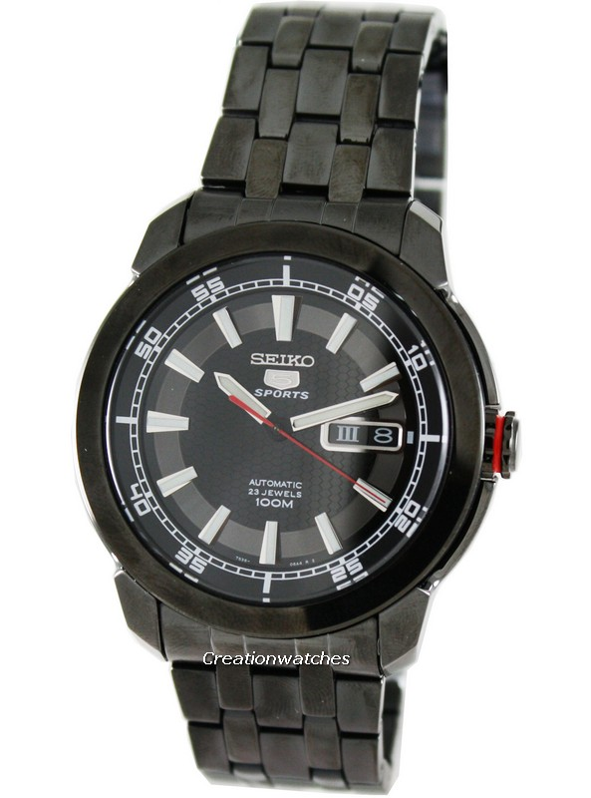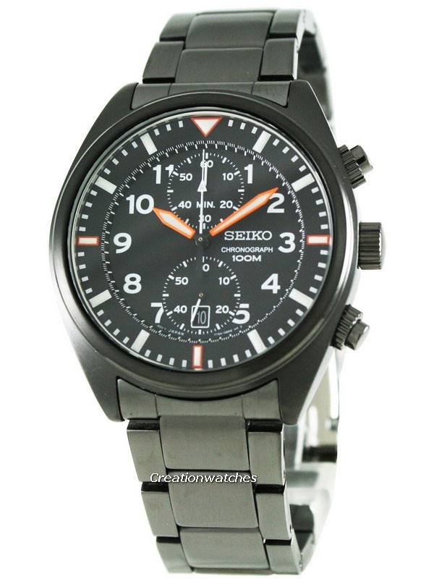
http://www.creationwatches.com/products/seiko-chronograph-watches-63/seiko-chronograph-snn237p1-snn237-snn237p-men-s-watch-2617.html
http://www.creationwatches.com/products/seiko-automatic-watches-69/seiko-5-sports-automatic-snzh67k1-snzh67-snzh67k-men-s-watch-2328.html
http://www.creationwatches.com/products/seiko-127/

