http://www.worldofwatches.com/detail.asp?iq=1&bo_products_id=&bo_products_variance_id=99558&rid=pricegrabber

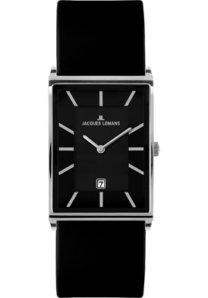$119,2
http://www.worldofwatches.com/detail.asp?iq=1&bo_products_id=&bo_products_variance_id=70694&rid=pricegrabber
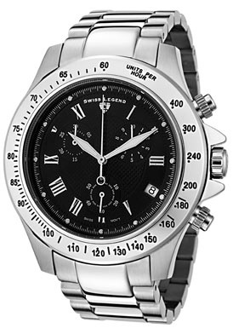$149.99

